This is an application of recursive algorithms. Here are the rules:

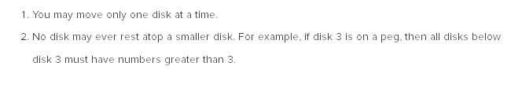

the general progression here will be to move out the smaller disc of the way to be able to move the one that is directly below.

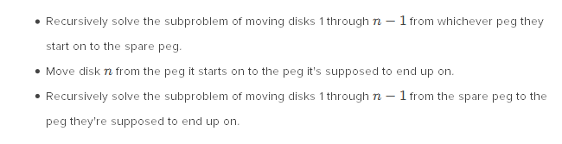

So, as we can see, we actually call the recursion twice inside the function: to move the n-1 disks out of the way, and to put them back on the biggest disc

This has a big O of O(2^n)

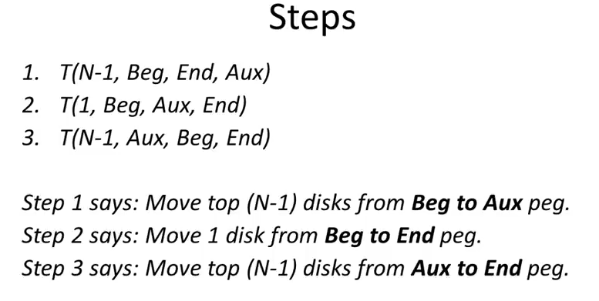

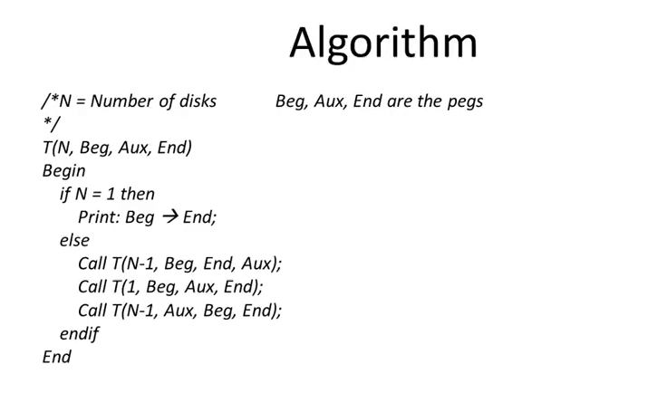

If we have only one disk, then we move it to the end peg. Otherwise, we TRIPLE recurse the algorithm, meaning we implement three instances of the recursion inside the function to go through with it. Each of these functions will continue writing code until it goes down to one, and then will go up again the code that it has stored

In practice, the trick is to tell “move your next disk to the right if you can, and otherwise, if you arrived to the end or you can’t move it to the left, move him to the immediate next possible left”.